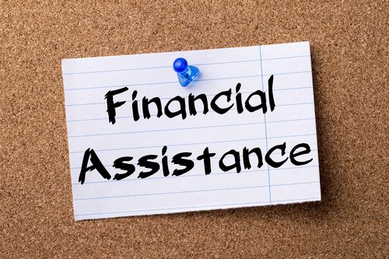

To help Michigan citizens facing economic hardship find the services they need, please see the attached list of available resources:

Michigan Helping Hands https://www.michigan.gov/helpinghand

State of Michigan – Department of Health & Human Services (810) 966-2000
https://www.michigan.gov/mdhhs/inside-mdhhs/county-offices/east-michigan/st--clair-county
220 Fort Street, Port Huron, MI 48060

Blue Water Community Action Agency (810) 982-8541
https://www.bwcaa.org/
3403 Lapeer Ave, Port Huron, MI 48060

Salvation Army (810) 985-8169
https://centralusa.salvationarmy.org/porthuron/
1723 Military St., Port Huron, MI 48060

St. Vincent De Paul/Our Lady on the River Parish/Holy Cross Catholic Church (810) 765-3568 x 14
https://ourladyontheriver.net/
610 S. Water St., Marine City, MI 48039

Down River Helping Hands (810) 765-3848
https://www.freefood.org/l/downriver-helping-hands
310 S. Parker St., Marine City, MI 48039

Marine City Lions Club (810) 765-9121
545 Ward St., Marine City, MI 48039

Wayne Metro Energy & Water Assistance Program (313) 388-9799
https://www.waynemetro.org/energy-and-water-assistance/

Michigan Homeowner Assistance Fund (MIHAF) (844) 756-4423
MSHDA-HO-HAF-Program@michigan.gov
https://www.michigan.gov/mshda/homeownership/mihaf-homeowner-assistance

