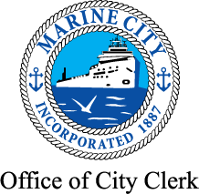

CITY OF MARINE CITY
NOTICE OF

PUBLIC ACCURACY TEST

Please take notice that the public testing of the tabulators and the program to be used for tallying the results of the Primary Election on August 2, 2022 will be held on Wednesday, July 6, 2022 at 9:30 am. The test will take place at the Marine City Municipal Offices located at 260 South Parker Street, Marine City, Michigan. All interested parties are invited to observe.

Shannon M. Adams
City Clerk
June 21, 2022

