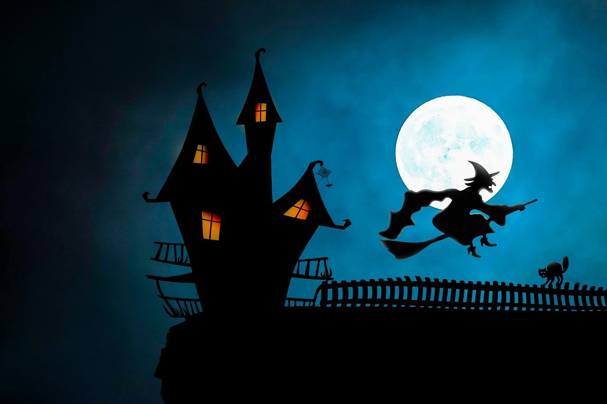

Halloween
Trick or Treating Hours
Monday, October 31, 2022
5:00 P.M. – 8:00 P.M.

